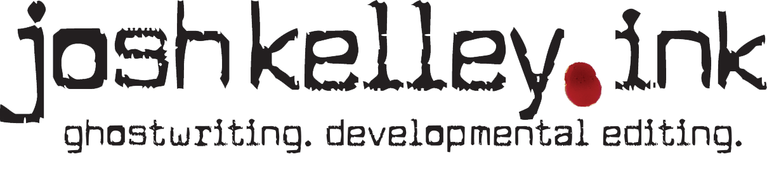
Greetings! I look forward to chatting with you.
Think of our meeting as a cross between a job interview and a coaching session. I’ve discovered that the more I know going in, the better I’ll be able to help you. Hence, this questionnaire. It’s also a good way to discover if someone is serious about this!
Please answer the questions below as best you can and email it to me no later than two days before our meeting. If you can’t complete it in time, just let me know and we’ll reschedule.
By the way: There are no wrong answers, and this is NOT a test of your knowledge or writing ability, so don’t worry too much about grammar and spelling! Feel free to message me with any questions.
- Have you read the “My Services” page of my website and are you able to make the financial investment required?

- What is your book’s big idea? What’s it about?

- What is your book’s purpose? How do you want it to affect the reader?

- What is your personal goal? Why is this important to you? For example, are you trying to establish your authority, build a business, or wrestle with your own story?

- Do you want your book to be traditionally published, self-published, either, or neither?

- Who is your ideal audience? Contrary to popular opinion, the narrower your audience, the better. Think about their age, religious background, gender, and interests.

- It’s equally important to know who you are NOT writing to. Whose disapproval would feel like a compliment?

- What are you hoping I can do for your project?

- How much writing experience do you have?
❒ I hate writing
❒ I’m a decent writer, when I need to be
❒ I enjoy writing and want to get better at it
❒ I consider myself a professional/semi-professional writer

- How much do you know about the publishing industry?
❒ I’ve seen a book before
❒ I’ve started studying the industry
❒ I know a query from a proposal and much more
❒ I’ve been published

- Finally, do you have any questions for me?

